Contents

Site Description 1

Users and Purposes 2

User 1: 2

User 2: 2

User 3: 3

Flaw Analysis 4

Home page 4

Navigation 5

Layout 5

Color 5

Fonts 5

Locations page 5

Navigation 7

Layout 7

Color 8

Font 8

Careers Page 8

Navigation 9

Layout 10

Color 10

Font 10

Alternatives / Competitor Analysis 11

Home Page: 11

Menu: 12

Call Ahead / Wait List: 12

Career Information: 13

Proposal 15

# Site Description

Site being analyzed: saltgrass.com

As a privately-owned business, Saltgrass Steakhouse relies solely on the appeal of their goods and services. Consumers must be persuaded to eat the food prepared by the restaurant, and convinced that they will be easily seated within a reasonable amount of time. Additionally, individuals should be able to apply for available positions at the restaurant. The Saltgrass Steakhouse website is a tool to accomplish the three main goals of the users.

This document will serve to outline key areas where this site fails in ease of use and design by analyzing the difficulty of completing certain tasks pertaining to what this site serves to accomplish. We will point out these areas through visuals, as well as example user experiences.

# Users and Purposes

Saltgrass Steakhouse Users generally fall into 1 of 3 categories:

* A consumer interested in viewing the menu and prices
* A consumer who wants to make a reservation or call ahead for seating
* An individual interested in applying for a job

These 3 different types of users will navigate your website differently based on their specific goals.

## User 1:

Jane Doe is a stay at home mom and she is planning a rehearsal for her oldest son.

* Jane Doe
* Age: 45
* Occupation: Stay at home mom and volunteer in many of her children’s activities
* Hometown: San Antonio, Texas
* Interests: saving money, pleasing kids, impressing people

Consumers view the Saltgrass menu for 3 reasons. For people like Jane, Saltgrass Steakhouse (1) serves a wide variety of foods (2) the prices vary from location to location (3) food accommodations for special dietary requirements

## User 2:

John Smith is an engineer at Devon Energy. He is a husband and an engaged father who likes to please his impatient children.



* John Smith
  + Age: 27
  + Occupation: engineer at Devon Energy
  + Hometown: Oklahoma City, Oklahoma
  + Interests: having a good time with his family, not waiting long for seating, eating out

Consumers view the Saltgrass website about call ahead seating for 3 reasons. For people like John Saltgrass Steakhouse (1) has call ahead seating (2) allows consumers to make reservations (3) will provide contact information for wait times.

## User 3:

Ron Swanson is a professional steak chief and is looking to apply for a job.



* + Ron Swanson
  + Age: 19
  + Occupation: Professional Steak Chef
  + Hometown:
  + Interests: finding a new job, not spending large amounts of time looking for one, and showing the world his talents

Individuals view the Careers page on the Saltgrass Steakhouse website for jobs that are available for 3 reasons. For people like Ron Swanson Saltgrass Steakhouse (1) has job availability for different positions (2) shows requirements of the jobs (3) provides locations for specific jobs

# Flaw Analysis

During this step of the consulting process, we will review the three most significant pages of your website: the home page, the locations page, and the careers page. Our focus is how to improve the navigation, layout, color, and fonts. Things that will not be covered are, word choice, picture selection, and basic grammar.

## Home page

Often, a first impression is the key to engaging a user. Like a weak handshake that brings mistrust to a new relationship, a poor designed home page can overwhelm and frustrate a

users. Your home page looks good for the most part, but needs a few changes to make it easier and helpful to your users. We have provided a few ways that you can use for your site to better assist those who use it.

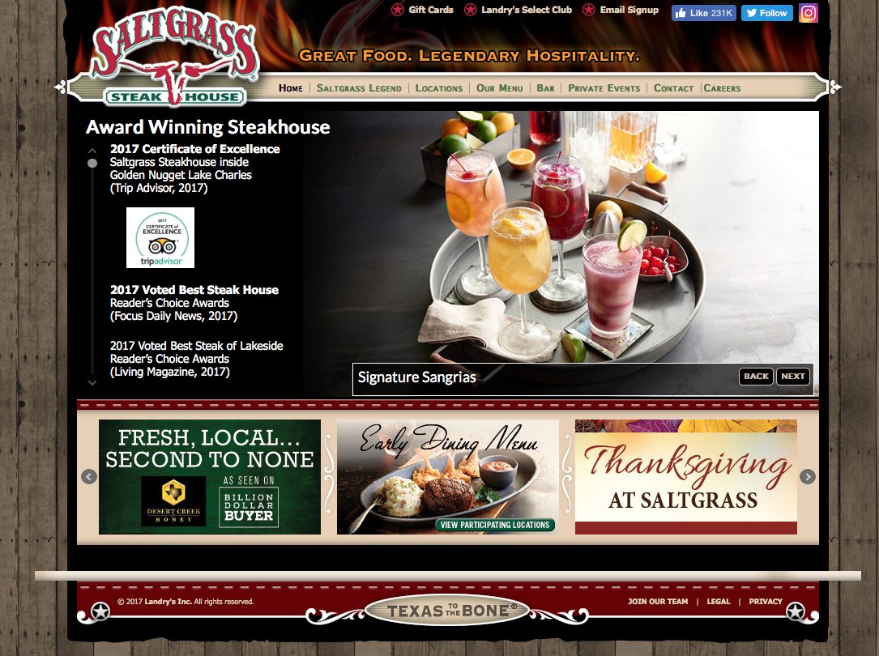

Reorganize links by priority

Add a search bar here

Do not use sliders

Figure 1.: Home Page

### Navigation

First thing that stuck out to us was the home page not having a search bar. The search bar is an important factor in having a well-organized website. If a user needs to find something quick on the website, they would not be able to since the search bar is not available. Our solution for this is labeled in **Figure 1.1** above with a good location picked out.

### Layout

The overall theme of the home page layout fits that of a good steak house. It would grab a steak enthusiast attention by the southern look it tries to perceive. However, there are quite a few mistakes that need to be addressed;

* There are too many advertisements.
* There are rotating images (“slider”) throughout the homepage.
* Your “Saltgrass Legend” section is the first item on the navigation bar, and is something that is not usually a high priority for someone visiting at this site.
* Having all your awards on the front page.

We have labeled areas in **Figure 1.1** above to show where these possible mistakes are located. We have also provided solutions to the mistakes we have listed;

* If you are going to use advertisements, make them smaller and move them into a corner.
* Use single images and place them in an order that looks nice.
* Move the “Saltgrass Legend” farther to the right since it has a smaller priority.
* Move your awards to the navigation bar, because not every user will care to look at them.

### Color

We love the color scheme: the dark red, light brown, bright white, and blacks all flow wonderfully. The flames have a great tone of color to make them feel warm. The fence for the second background has a nice light brown that gives them a rustic look. We noticed that the links on the home page have a light color to them. Maybe try and make them bolder to let the viewer know that they are links.

### Fonts

Sans serif was a decent decision; however, your site will appear more rustic if you move away from Open Sans. We feel that the font should be changed throughout the whole website. You should try and match the font of your logo. It will give the website that rustic look we had just mentioned.

## Locations page

For you to achieve your goals of enticing and sustaining customers, this webpage needs to be as close to perfect as imaginable; it is where you want your customers to spend the least amount of time online and more in each restaurant.

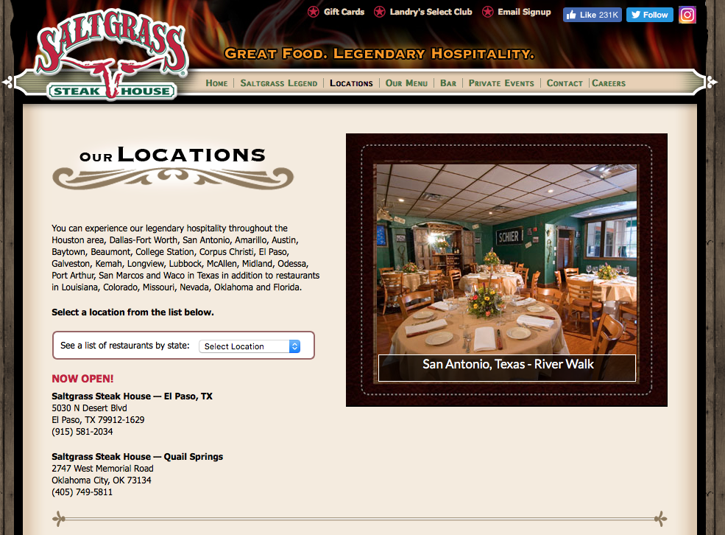

Poorly designed

Avoid using slider

Figure 1.2: Locations Page

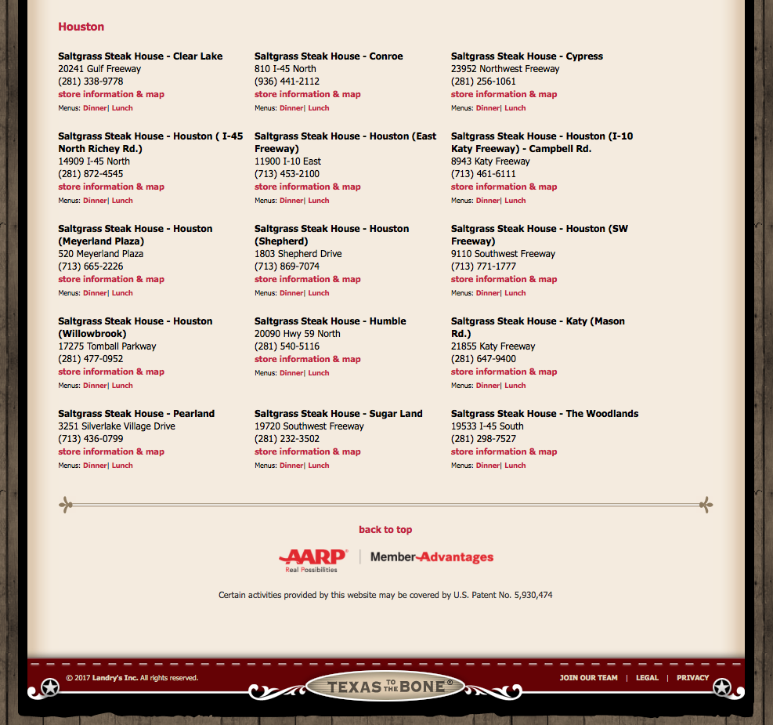

Figure 1.3: Locations Page Continued

Why does the first location come up as Houston?

### Navigation

The navigation bar stayed the same for the most part once the “locations tab” was selected. The only difference is the “locations tab” was bolded and changed to a black font. The website is still missing a search bar and will continue to make searching for a specific location difficult.

### Layout

The website layout has changed slightly, but still has rotating images that are not necessary. It is odd that the first location listed is for Houston, Texas as shown in Figure 3 above. You only need to keep the “see a list of restaurants by state:” tab, because users need to feel like this restaurant is special for any state. The links listed on this page are small and not easily identifiable as links. This page is time consuming because it is also the page that you must go through to find a menu for a specific location.

### Color

The colors are the same as the home webpage. Maybe try and mix in some other dark colors to help with that rustic look you are going for.

### Font

Most of the issues with the font are simple fixes that were easy to overlook when creating this webpage. The sub-header for “Our Locations” uses two different font sizes which makes it look uneven. Try and keep them the same size for more even look.

## Careers Page

The careers page is a great way to bring in potential employees. You want this to page to look professional and easy to use. Not all future employees know how to work a computer.

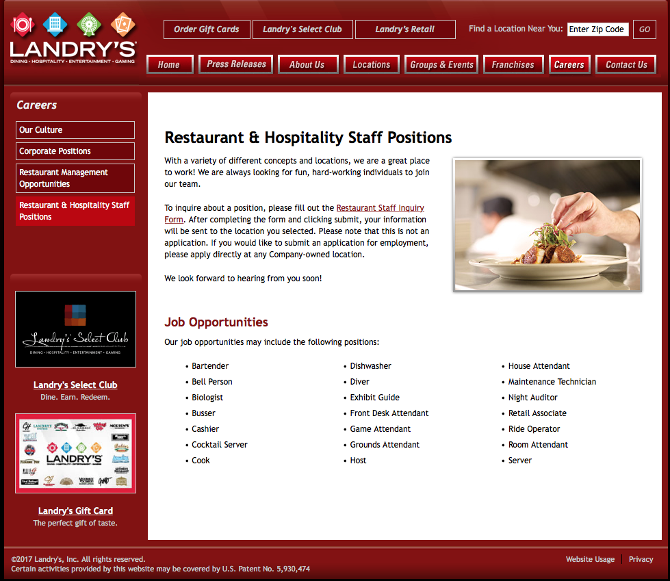

This link is not very visible

Again, get rid of this

Why not show what is currently available?

Figure 5: Restaurant & Hospitality Staff Positions Page

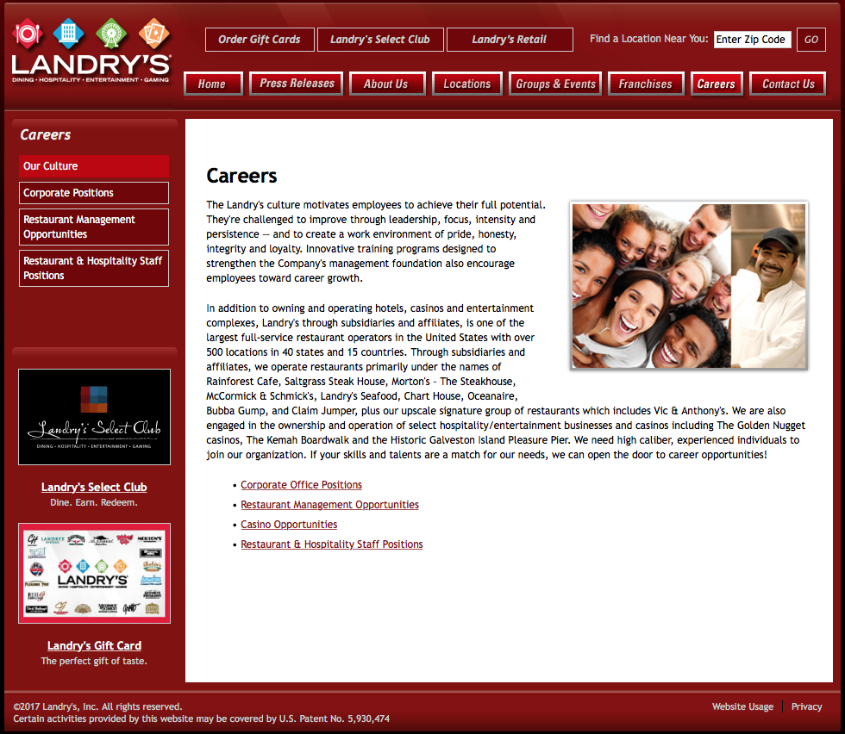

Too many links

No need for advertisement on a hiring page

These links do not match

Figure 4: Careers Page

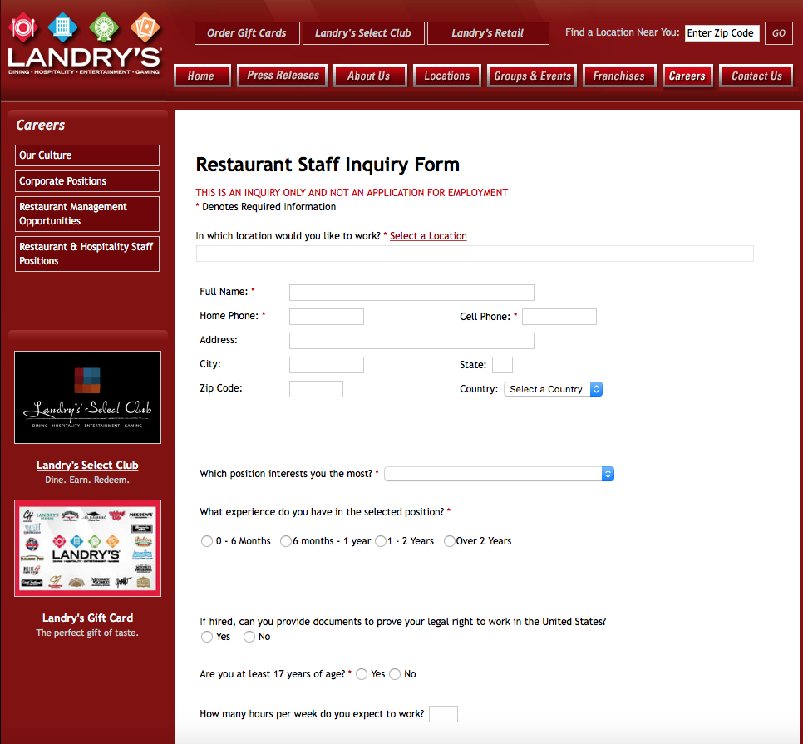

Get rid of this!

Then what is the point of this form then?

Figure 1.4: Restaurant Staff Inquiry Form

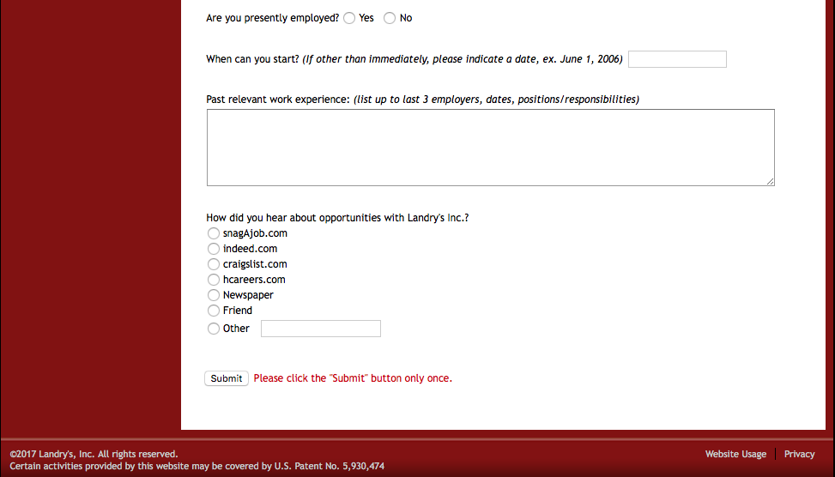

These are for actual jobs, not inquiry’s

Figure 1.5: Restaurant Staff Inquiry Form Continued

### Navigation

The first thing we had a problem with was clicking the “careers tab” on the navigation bar from the home page. It opens another page in the web browser and can be confusing and frustrating for your future employees. We see you added a search bar for this page, but it is only for entering zip codes. Try and add an all in one search bar in that same location as shown in **Figure** **1.1**. It is confusing and unnecessary to have two sets of links that are pretty much the same.

### Layout

The layout of each linked page is basically the same in terms of look and usability. The use of all the bullets in “Job Opportunities” in **Figure 1.4** above is very overwhelming and can be time consuming for the users. We suggest use a drop-down menu that will allow the user to look up a position in an alphabetical order.

### Color

The coloring in **Figures 1.4 and 1.5** are all the same plan red and whites. Try and add some variation to keep the user attracted to each page they go to. Good coloring can keep the user focused, which will help them fill out the job inquiry form more accurately.

### Font

Your fonts seem to be the same for each page as shown in **Figures 1.4 and 1.5**. There is a point when a website is trying to be to professional. This will cause you to lose interest in your user and make them not want to read everything you must say on each webpage. Try and change the sub-headings to a different font to show the importance of each section the user might read through.

# Alternatives / Competitor Analysis

Competitor being analyzed: Outback Steakhouse (outback.com)

Outback Steakhouse’s website works in a more user friendly and user efficient manner in accomplishing the same tasks that Saltgrass’ website attempts to accomplish in a number of ways. We will analyze Outback’s website in comparison to Saltgrass’ through examining its homepage, its menu page, its call ahead / wait list page, and its career information page.

## Home Page:

Overall, Outback’s homepage is less busy and more refined in appearance than Saltgrass’. Its color scheme follows the 60-30-10 rule that is recommended for good website layout design. Additionally, the homepage’s navigation bar’s font size is large and easily readable, with each navigation option offering helpful and descriptive text detailing where each option leads to. Finally, although this page has a slider (which is not necessarily recommended for good design), the slider itself has a small number of pictures that moves slowly through each one, while each image itself follows the same color scheme as the site and contains pertinent information to the user. Finally, the homepage is not cluttered with advertisements and sponsors, thus improving the look of the website and keeping unneeded information out of the user’s field of view. All of this can be seen through viewing **Figure 2.1**.

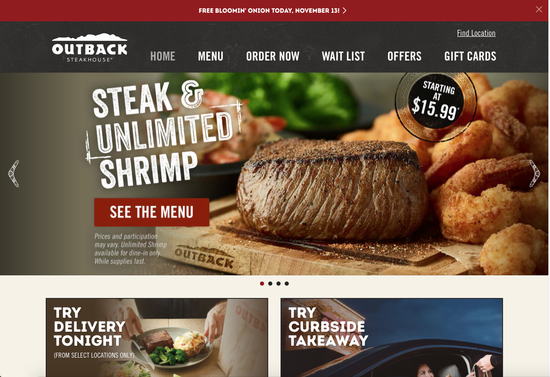

Large navigation bar

Few items in slider, and slider moves slowly

Figure .1: Home page isn’t overly busy, and color scheme roughly follows 60-30-10 rule. Navigation bar is large and informative, and slider is slow moving with few images.

## Menu:

If we navigate as user Jane Doe would, we would attempt to locate the menu for Outback to view food items and pricing. The menu on this site is very easily accessible as it is one of the main navigation options located on the navigation var. Clicking on the menu navigation option shows us the menu directly, and does not redirect us to another site or require us to download a PDF of the menu to view. Additionally, the menu is not location specific, and navigating the menu itself is easy due to the large navigation text within the various menus offered. This reduces the total number of clicks needed by the user, thus improving overall usability and friendliness. All of this can be seen in **Figure 2.2.**

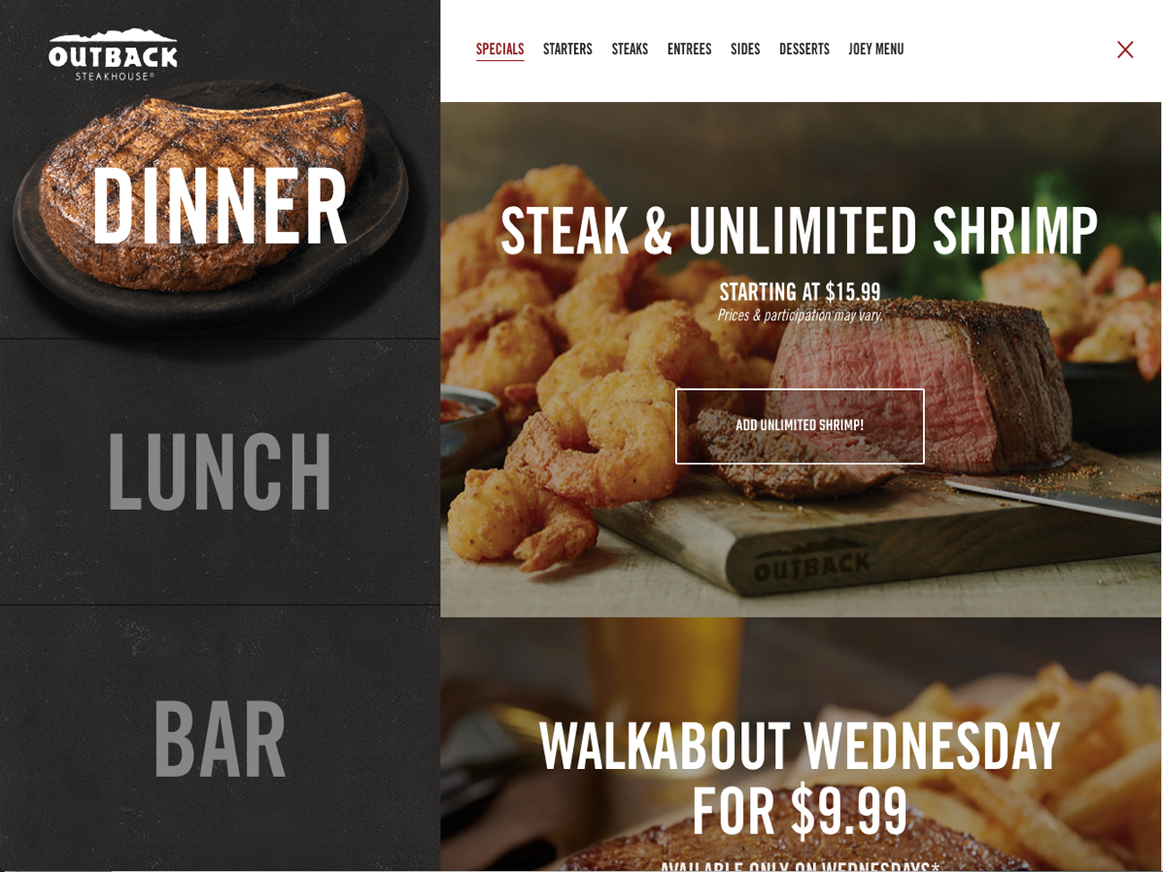

Easily navigable and informative menu headings

Menu is native to website, with large navigation buttons

Figure 2.2: The menu available on Outback Steakhouse’s website is easily navigable, shows prices and menu items clearly, and is native to the original website (doesn’t require redirection to another site / downloading a PDF)

## Call Ahead / Wait List:

Finding call ahead and wait list information for a specific Outback location, something that user John Smith would attempt to do, is easy and intuitive on Outback’s site. One of the main navigation options on the navigation bar is labeled “Wait List”, and clicking on this option leads us to the call ahead / wait list page. This page has very little unnecessary text and is uncluttered. A text box prompts user to enter the zip code they are in, and then displays Outback’s that are local to that zip code. This is a much more intuitive way of searching for specific information than a drop-down menu. Contact information is displayed clearly after specifying a zip code, and a map is displayed next to the listed contact information for a more exact location description. Finally, these features are native to Outback’s site, and do not require any redirections or downloads. All of this can be seen in **Figure 2.3.**

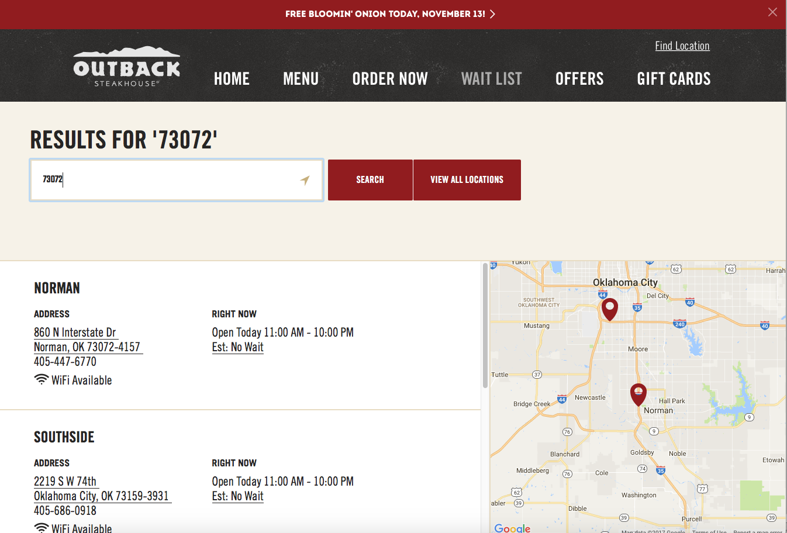

Search for specific zip code, rather than a drop down

Contact info and address easily viewable

Map available showing exact location

Figure 2.3: Searching for call ahead information is easily done on Outback’s website through their “Wait List” page.

## Career Information:

If we navigate like user Ron Swanson would, we would attempt to find information about available positions at outback as well as information on how to apply. Obtaining this information on Outback’s site is native to the site itself, and can be found by clicking on the “Careers” navigation option. This page allows us to search for job openings based off a number of different criteria that can be selected through different drop-down menus that are large and clearly visible. When we select a specific position, the page does redirect us to the restaurants parent site for application information, but this is only done after finding available openings for specified positions, rather than when clicking on the “Careers” navigation option. All of this can be seen in **Figure 2.4.**

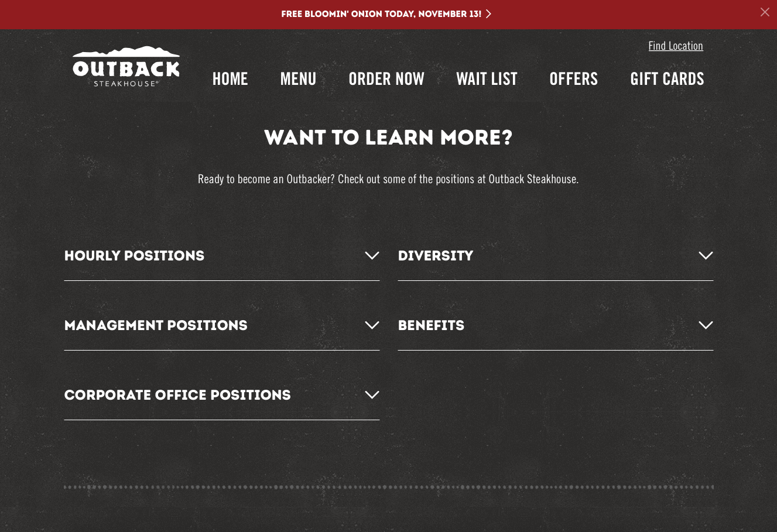

Career search through position & location

Native to outback.com

Figure 2.4: Finding career information is native to ouback.com, and searchable by position and location.

# Proposal

In conclusion, we recommend that you allow us to run a usability test for your website. Usability tests are a series of tests designed around “watching people try to use what you’re creating/designing/building (or something you’ve already created/designed/built), with the intention of (a) making it easier for people to use or (b) proving that it is easy to use.”[1] Essentially, this test will allow us to find specific areas of improvement for your site through actively testing users on specific tasks.

We propose a quantitative usability test (one which seeks to prove something, in this case whether your site is user friendly) which will involve asking participants who have never used your website before to perform basic functions and / or search for specific information on your site. This test will be in a controlled environment, and all information from the test will be observed from members of our team to determine pain points and areas for improvement for your site.

Since a large part of your site’s traffic will be searching for a menu to view food items and pricing, call ahead for seating, and gaining information on applying for a server position at Saltgrass, a majority of this usability test will be focused on completing objectives involving these three areas. We will ask users to perform the following tasks:

* Navigate to a dinner menu from the home page, and find the price of a cheeseburger.
* Navigate to a page containing contact information for the Norman, Oklahoma Saltgrass location.
* Navigate to the applications page for a server at Saltgrass

In order for a usability test to be considered quantitative, specific data points must be collected and analyzed so as to measure the success rates of assigned tasks. We will use the following quantitative data to measure the overall usability of your site:

* Total time for completing each task
* Total number of clicks it takes to complete a task
* Total number of misdirections (navigating to an area of the site which does not contain information leading to or information pertaining to the completion of a task)

This testing will be done by outlining the above tasks for a user and observing the user complete said tasks with as little interaction from those giving the test and those taking the test as possible so as to avoid influencing the results. The user taking the test will be observed by 3 people in total: a narrator who will outline the tasks for the user, a note taker who will observe the test and its participant, and a follow up observer who will ask extra questions during and after each task is complete.

Upon completing this usability test, we will report back to you on our findings with this quantitative information, and work with you on possible solutions for your site if you so choose.

1. Steve Krug’s *Rocket Surgery Made Easy: The Do-It-Yourself Guide to Finding and Fixing Usability Problems*